Item | Specification
Paper size | A4, printed on one side
Margins | Left 1.25" (binding side); Right, Top and Bottom 1"
Font | Times New Roman throughout (code: Courier New, 9–10 pt)
Chapter heading | 16 pt, bold, upper case, centred; each chapter starts on a new page
Section / sub-section heading | 14 pt bold (e.g., 1.1) / 12 pt bold (e.g., 1.1.1)
Body text | 12 pt, justified, 1.5 line spacing
Page numbers | Bottom centre; roman (i, ii, iii …) for preliminary pages, arabic (1, 2, 3 …) from Chapter 1
Figures | Numbered chapter-wise (Figure 4.1); caption centred below the figure; referred to in the text
Tables | Numbered chapter-wise (Table 3.1); caption centred above the table; referred to in the text
Equations | Numbered chapter-wise, e.g., (4.1), right aligned
References | IEEE style; cited in the text as [1], [2] … in order of first appearance
Recommended length | 25–40 pages excluding appendices
Originality | The report must be the original work of the team; every source (papers, datasets, code, images) must be cited
Evaluation criterion | Marks | Where it is demonstrated in the report
a) Social & Technical Relevance | 5 | Chapter 1 (Sections 1.2 – 1.4)
b) Extent and Quality of Literature Review | 5 | Chapter 2
c) Effectiveness & Presentation of Methodology | 5 | Chapters 3 and 4
d) Quality of Work & Results | 5 | Chapters 5, 6 and 7
g) Project Report | 15 | Entire report: structure, analysis, originality, formatting, references, language
A PROJECT REPORT ON
AI-BASED SMART TRAFFIC VIOLATION DETECTION USING
Submitted in partial fulfilment of the requirements for the course
24ESQ2119(B)-C ARTIFICIAL INTELLIGENCE AND
DATA SCIENCE PROJECT
(Introductory Level Artificial Intelligence for Engineers – Project)
of the degree of
BACHELOR OF TECHNOLOGY
in
ELECTRONICS AND COMPUTER & ROBOTICS AND AUTOMATION
Submitted by
Abiya Elizabeth Jomon [MGP24RA009]
Bilal Muhammed S [MGP24RA039]
Fidah Fathima [MGP24ECE023]
Afaf Nourin Rizwan [MGP24ECE004]
Under the guidance of
DR.JITHIN KURIAN ANDREWS
Assistant Professor (Senior), Department of Civil Engineering

DEPARTMENT OF ELECTRONICS
SAINTGITS COLLEGE OF ENGINEERING (AUTONOMOUS)
Kottukulam Hills, Pathamuttom P.O., Kottayam – 686 532, Kerala
OCTOBER 2026
SAINTGITS COLLEGE OF ENGINEERING (AUTONOMOUS)
DEPARTMENT OF ELECTRONICS

CERTIFICATE
This is to certify that the project report entitled “AI-BASED SMART TRAFFIC VIOLATION DETECTION SYSTEM” submitted by Abiya Elizabeth Jomon [MGP24RA009],Bilal Muhammed S[MGP24RA039],Fidah Fathima[MGP24ECE023] and Afaf Nourin Rizwan [MGP24ECE004] in partial fulfilment of the requirements for the course 24ESQ2119(B)-A Artificial Intelligence and Data Science Project of the degree of Bachelor of Technology in Robotics and Automation AND Electronics and Computer, Saintgits College of Engineering (Autonomous), is a bonafide record of the project work carried out by them under our guidance and supervision during the academic year [2026– 2027].
Project Supervisor | Project Coordinator | Head of Department
Dr. Jithin Kurian Andrews, Assistant Professor (Senior) | Er. Gokulnath G, Assistant Professor | Department of Electronics
Place: Pathamuttom
Date: 30 October 2026
(Department Seal)

DECLARATION
We hereby declare that the project report entitled “AI-Based Smart Traffic Violation Detection System”, submitted in partial fulfilment of the requirements for the course 24ESQ2119(B)-A Artificial Intelligence and Data Science Project of the degree of Bachelor of Technology in Electronics and Computer and Robotics and Automation of Saintgits College of Engineering (Autonomous), is a bonafide record of the work carried out by us under the supervision of Dr. Jithin Kurian Andrews. This report has not been submitted, either in part or in full, for the award of any other degree or course. All sources of information, data and code used in this work have been duly acknowledged.
Sl. | Name of the Student | Register No. | Signature
1 | Abiya Elizabeth Jomon | MGP24RA009
2 | Bilal Muhammed S | MGP24RA039
3 | Fidah Fathima | MGP24ECE023
4 | Afaf Nourin Rizwan | MGP24ECE004
Place: Pathamuttom
Date: 30 October 2026

ACKNOWLEDGEMENT
We express our sincere gratitude to Dr. Sudha T, Principal, Saintgits College of Engineering (Autonomous), for providing the facilities required for this project. We thank the Head of the Department of Electronics for the support and encouragement provided throughout this work.
We are deeply indebted to our project supervisor, Dr.Jithin Kurian Andrews,Assistant Professor(Sr),for the valuable guidance, suggestions and supervision throughout the course of this work. We also thank Er.Gokulnath G,Project Coordinator, and the members of the project evaluation committee for their constructive feedback during the reviews.
Finally, we thank our parents, friends and all those who helped us directly or indirectly in the successful completion of this project.

Abiya Elizabeth Jomon,Bilal Muhammed S,Fidah Fathima,Afaf Nourin Rizwan

ABSTRACT
The increasing number of road traffic violations presents a significant challenge to traffic authorities, particularly in identifying vehicles crossing red lights and motorcycle riders travelling without helmets. Manual traffic surveillance requires continuous human attention and makes the identification, recording and verification of violations time-consuming. To address this problem, this project proposes an AI-Based Smart Traffic Violation Detection System that uses computer vision, deep learning and multi-object tracking to analyse traffic video footage and identify potential violations. The system is relevant to road safety, intelligent transportation systems and smart-city monitoring, as it can assist traffic authorities in reviewing suspicious events and maintaining organised evidence records.
The helmet detection module uses the Motorcycle Helmet Detection Version 2 dataset obtained from Roboflow Universe, containing 2,215 annotated images divided into 1,545 training images, 438 validation images and 232 test images. The dataset includes four classes: full-faced helmet, half-faced helmet, invalid helmet and no helmet. Images are resized to 640 × 640 pixels and processed in YOLO format with bounding-box annotations. The system uses YOLOv8 for object detection, ByteTrack for tracking vehicles across video frames, and rule-based stop-line crossing and traffic-signal analysis to identify potential red-light violations. A separate YOLO-based model detects helmet-related classes, using repeated predictions to improve decision consistency. On the held-out test dataset, the helmet detection model achieved 63.91% precision, 54.61% recall, an F1-score of 58.90%, mAP@50 of 59.03% and mAP@50–95 of 33.57%. In a video demonstration, 1,022 frames were processed, with 19 potential red-light events and two potential no-helmet events flagged. These results demonstrate the feasibility of integrating AI-based detection, tracking and evidence generation into a common traffic-monitoring pipeline. However, further training, testing under diverse real-world conditions and manual verification are required before operational deployment.
Keywords: Artificial Intelligence, Computer Vision, YOLOv8, ByteTrack, Helmet Detection, Traffic Violation Detection

CONTENTS
CERTIFICATE i
DECLARATION ii
ACKNOWLEDGEMENT iii
ABSTRACT iv
CONTENTS v
LIST OF FIGURES vii
LIST OF TABLES viii
LIST OF ABBREVIATIONS ix
CHAPTER 1: INTRODUCTION 1
1.1 Background 1
1.2 Problem Statement 1
1.3 Objectives 1
1.4 Social and Technical Relevance 1
1.5 Scope and Limitations 1
1.6 Organisation of the Report 1
CHAPTER 2: LITERATURE REVIEW 2
2.1 Review of Existing Works 2
2.2 Summary of Literature Review 2
2.3 Limitations of Existing Systems and Research Gap 2
2.4 Feasibility Study 2
CHAPTER 3: SYSTEM REQUIREMENTS AND SPECIFICATION 3
3.1 Software and Hardware Requirements 3
3.2 Dataset Description 3
CHAPTER 4: METHODOLOGY AND SYSTEM DESIGN 5
4.1 Proposed System Overview 5
4.2 System Architecture 5
4.3 Data Pre-processing 5
4.4 Model Selection and Justification 5
4.5 Algorithm 5
4.6 Design Diagrams 6
4.7 Evaluation Metrics 6
CHAPTER 5: IMPLEMENTATION 7
5.1 Development Environment 7
5.2 Module Description 7
5.3 Sample Code 7
5.4 GitHub Repository 7
5.5 Real-time Implementation / Deployment 7
CHAPTER 6: RESULTS AND DISCUSSION 9
6.1 Experimental Setup 9
6.2 Performance Evaluation 9
6.3 Graphical Analysis 9
6.4 Comparison with Existing Works 9
6.5 Observations, Failures and Inferences 9
6.6 Objectives vs. Outcomes 10
CHAPTER 7: CONCLUSION AND FUTURE SCOPE 11
7.1 Conclusion 11
7.2 Future Scope 11
REFERENCES 12
APPENDIX A: SOURCE CODE 13
APPENDIX B: SCREENSHOTS 14
APPENDIX C: MAPPING WITH SUSTAINABLE DEVELOPMENT GOALS 15
APPENDIX D: INDIVIDUAL CONTRIBUTION OF TEAM MEMBERS 16

(If the contents list appears empty, right-click here and choose “Update Field” → “Update entire table”. In LibreOffice: Tools → Update → Update All.)

LIST OF FIGURES
Figure No. | Title | Page No.
4.1 | System architecture of the proposed system
4.2 | Training and evaluation workflow
5.1 | Generated evidence and annotated output
6.1 | Normalized confusion matrix of the helmet detector
B.1 | Helmet and red-light evidence outputs
Figures are listed in order of appearance in the report.

LIST OF TABLES
Table No. | Title | Page No.
2.1 | Summary of literature review
3.1 | Software and hardware requirements
3.2 | Description of dataset attributes
6.1 | Performance comparison of models
6.2 | Class-wise held-out test results

LIST OF ABBREVIATIONS
Abbreviation | Expansion
AI | Artificial Intelligence
AP | Average Precision
CSV | Comma-Separated Values
DL | Deep Learning
FPS | Frames Per Second
IoU | Intersection over Union
mAP | Mean Average Precision
ML | Machine Learning
UML | Unified Modeling Language
YOLO | You Only Look Once

CHAPTER 1: INTRODUCTION

Background

Road traffic violations are a major concern for road safety and traffic management. Violations such as jumping red signals and riding motorcycles without helmets can increase the risk of accidents and injuries. Identifying these violations through manual monitoring of traffic videos requires considerable time and continuous human attention. It can also make it difficult for traffic authorities to record and review every potential violation efficiently.
Recent developments in Artificial Intelligence (AI) and computer vision provide opportunities to automate parts of traffic monitoring. Object detection techniques can identify vehicles, motorcycles and persons in video frames, while object tracking can follow vehicles across multiple frames. These capabilities can be used to analyse vehicle movements and identify possible traffic violations. Similarly, helmet detection models can examine motorcycle riders and classify helmet-related conditions.
The AI-Based Smart Traffic Violation Detection System aims to combine these techniques to identify potential red-light violations and motorcycle helmet violations from traffic video footage. The system uses YOLOv8 for object detection, ByteTrack for vehicle tracking, and rule-based analysis of traffic-signal states and stop-line crossings to flag potential red-light violations. A separate YOLO-based model is used for helmet detection. The system also generates annotated videos, evidence images and CSV logs to support the review of detected events.
The project demonstrates how AI-based video analysis can assist traffic monitoring by reducing the effort required to identify and organise potential violations. The developed prototype is intended to support traffic authorities in reviewing suspicious events; further testing and real-world validation are required before practical deployment.

1.2 Problem Statement

Monitoring traffic violations is a challenging task because it requires continuous observation of traffic footage and the identification of specific violations. Red-light violations occur when vehicles cross a designated stop line while the traffic signal is red, while helmet violations occur when motorcycle riders travel without appropriate helmets. Identifying these violations manually can be time-consuming and may make it difficult to maintain consistent records of potential incidents.

The main problem addressed by this project is the need for an automated system that can analyse traffic video footage and identify potential red-light and motorcycle helmet violations. The system must detect and track vehicles, examine their movement in relation to a configured stop line and traffic-signal state, and classify helmet-related conditions for motorcycle riders. It should also record detected events and generate supporting evidence for further inspection.

To address this problem, the AI-Based Smart Traffic Violation Detection System integrates deep-learning-based object detection, multi-object tracking and rule-based violations. The system is designed as a prototype to assist traffic monitoring and simplify the review of suspected violations. Since detection errors may occur under different lighting, traffic and camera conditions, the flagged events require manual verification, and additional real-world testing is necessary before the system can be used operationally.

1.3 Objectives

The main objective of the AI-Based Smart Traffic Violation Detection System is to develop an AI-based prototype that analyses traffic video footage and identifies potential traffic violations. The specific objectives of the project are:

Vehicle Detection: To use the YOLOv8 object detection model to identify vehicles, motorcycles, buses, trucks and persons in traffic video footage.

Vehicle Tracking: To use ByteTrack to track detected vehicles across consecutive video frames and monitor their movement.

Red-Light Violation Detection: To identify potential red-light violations by analysing vehicle crossings at a configured stop line in relation to the traffic-signal state.

Helmet Violation Detection: To develop a helmet detection module that identifies helmet-related classes, including full-faced, half-faced, invalid and no helmet.

Violation Evidence Generation: To generate annotated videos and evidence images that help reviewers examine potential traffic violations.

Violation Logging: To maintain CSV logs of detected potential violations for systematic recording and further analysis.

System Evaluation: To evaluate the helmet detection model using precision, recall, F1-score, mAP@50 and mAP@50–95, and to identify areas requiring improvement.

Support for Traffic Monitoring: To demonstrate how AI-based video analysis can assist traffic monitoring and reduce the effort required to identify and review potential violations.

1.4 Social and Technical Relevance

Social Relevance

Road safety is an important social concern, and traffic violations such as red-light jumping and riding motorcycles without helmets can increase the risk of road accidents and injuries. The AI-Based Smart Traffic Violation Detection System aims to assist traffic monitoring by identifying potential violations from recorded video footage. By generating evidence images, annotated videos and structured violation logs, the system can help simplify the process of reviewing suspected incidents. It may also support efforts to improve traffic-rule compliance and promote safer road practices. However, the system is intended to assist human reviewers rather than replace manual verification.

Technical Relevance

The project demonstrates the application of Artificial Intelligence, deep learning and computer vision to traffic monitoring. YOLOv8 is used to detect vehicles, motorcycles and persons, while ByteTrack tracks detected objects across video frames. Rule-based analysis of traffic-signal states and stop-line crossings is used to identify potential red-light violations. A separate YOLO-based model classifies helmet-related conditions among motorcycle riders. The system also uses video processing and structured logging to generate annotated videos, evidence images and CSV records.
The project integrates multiple techniques into a common traffic-monitoring pipeline and evaluates the helmet detection model using precision, recall, F1-score and mean Average Precision (mAP). The results provide an initial assessment of the model's performance and highlight the need for further improvements. Additional training, testing under different traffic and environmental conditions, and manual verification are necessary to improve reliability before real-world deployment.

1.5 Scope and Limitations

Scope

The scope of the AI-Based Smart Traffic Violation Detection System is to develop a prototype that analyses traffic video footage and identifies potential red-light and motorcycle helmet violations. The system uses YOLOv8 for object detection and ByteTrack for tracking vehicles across video frames. Red-light violation detection is performed using a configured stop line and traffic-signal state analysis, while a separate YOLO-based model detects helmet-related classes, including full-faced, half-faced, invalid and no helmet.

The system processes video footage using computer vision techniques and generates annotated videos, evidence images and CSV logs of potential violations. The helmet detection model is evaluated using a held-out test dataset, with performance measured through precision, recall, F1-score, mAP@50 and mAP@50–95. The prototype demonstrates the integration of object detection, tracking and rule-based analysis into a common traffic-monitoring pipeline.

Limitations

The system has several limitations that must be considered. The performance of the helmet detection model is limited by its current evaluation results, and some violations may be missed or incorrectly classified. The detection process may also be affected by lighting conditions, camera angles, object occlusion, video quality and variations in traffic scenes. Red-light violation detection depends on the correct configuration of the stop line and traffic-signal state.

The system has been demonstrated using video footage, and the detected events represent potential violations rather than confirmed offences. Manual verification is therefore required before taking any action. The prototype also requires additional training, testing with diverse real-world traffic videos and further validation to assess its reliability in practical environments. Consequently, it should be considered an assistance tool for traffic monitoring rather than a fully autonomous enforcement system.

CHAPTER 2: LITERATURE REVIEW

2.1 Review of Existing Works

The development of an AI-based traffic violation detection system requires the study of existing methods for object detection, multi-object tracking, motorcycle helmet detection and red-light violation identification. Several research works have demonstrated the use of deep learning and computer vision for analysing traffic scenes. The following review discusses relevant methods, their findings and their limitations.

1. You Only Look Once (YOLO) for Object Detection

Redmon et al. [1] proposed You Only Look Once: Unified, Real-Time Object Detection, which introduced a single-stage object detection approach. Unlike methods that perform object localisation and classification in separate stages, YOLO processes an image through a single neural network to predict object classes and bounding boxes. This approach supports fast object detection and is suitable for applications that require the analysis of successive video frames. However, detection performance may be affected by small objects, overlapping objects and complex scenes. In the proposed project, YOLO-based detection is used to identify vehicles, motorcycles and persons from traffic footage.

2. Improved YOLOv5 for Motorcycle Helmet Detection

Jia et al. [2] proposed a real-time motorcycle helmet detection method using an improved YOLOv5 detector. Their approach consists of two stages: detecting motorcycles and motorcyclists from traffic surveillance footage, followed by determining whether riders are wearing helmets. The authors incorporated triplet attention and soft non-maximum suppression to improve detection. Their reported results included 97.7% mean Average Precision (mAP), a 92.7% F1-score and a processing speed of 63 frames per second under their experimental conditions. Although the results demonstrate the potential of deep learning for helmet detection, performance may vary with dataset characteristics, occlusion, camera angles and traffic conditions. This work provides a foundation for the helmet detection module in the proposed system.

3. ByteTrack for Multi-Object Tracking

Zhang et al. [3] introduced ByteTrack, a multi-object tracking method that associates both high-confidence and low-confidence detection boxes with existing object tracks. The method aims to recover objects that might otherwise be missed because of occlusion or low detection confidence. The authors evaluated ByteTrack on established tracking benchmarks, including MOT17, and reported 80.3% Multiple Object Tracking Accuracy (MOTA), 77.3% Identification F1-score (IDF1) and 63.1% Higher Order Tracking Accuracy (HOTA) on the MOT17 test set, with a reported processing speed of 30 frames per second on a V100 GPU. Nevertheless, tracking can still become difficult when objects overlap heavily, disappear from the camera view or change appearance. The proposed project uses ByteTrack to maintain vehicle identities across video frames and support the analysis of vehicle movement.

4. Automated Detection of Traffic Violations at Intersections

The study Automated Detection of All Kinds of Violations at a Street Intersection Using Real-Time Individual Vehicle Tracking [4] presented a system for detecting violations such as red-light running, speed violations, stop-line violations and lane violations. The approach combined vehicle tracking, trajectory analysis, traffic-signal phase information and vehicle-speed measurements. It also used cameras and road sensors to support violation identification and evidence collection. This work demonstrates the importance of analysing vehicle movement in relation to traffic rules rather than relying only on object detection. However, the described setup depends on dedicated sensing infrastructure and integration with the traffic-signal controller. The proposed project adopts a software-based approach using video frames, object tracking and configurable stop-line analysis.

5. YOLO-Based Licence-Plate Detection for Non-Helmeted Motorcyclists

Anilkumar et al. [5] investigated real-time licence-plate detection for non-helmeted motorcyclists using YOLO and centroid tracking. Their method focuses on locating vehicle registration plates and tracking detected objects to support identification. The study reported an overall licence-plate detection rate of 98.52% under the authors' experimental conditions. However, licence-plate detection and helmet detection are different tasks, and the reported result does not establish the accuracy of helmet classification. Performance can also depend on plate visibility, image quality and camera angle. This work is relevant to the future extension of the proposed system, where automatic number-plate recognition could be integrated after potential violations have been identified and verified.

6. YOLOv8 for Modern Object Detection

Ultralytics [6] provides technical documentation for YOLOv8, including its model variants and workflows for training, validation, inference and evaluation. YOLOv8 supports object detection and other computer vision tasks through a common software interface. Pretrained models can be adapted to custom datasets, making the framework useful for applications such as traffic monitoring. However, official model documentation is not independent evidence of the accuracy of a particular project. Actual performance depends on the selected model, training data, class definitions and evaluation conditions. In this project, YOLOv8 is used for detecting traffic participants, while a separate YOLO-based model is used for helmet-related classifications.

7. Motorcycle Helmet Detection Dataset from Roboflow Universe

The Motorcycle Helmet Detection — Version 2 dataset available through Roboflow Universe [7] provides annotated images for training and evaluating helmet detection models. The dataset used in this project contains 2,215 images divided into 1,545 training images, 438 validation images and 232 test images. It includes four classes: full-faced, half-faced, invalid and no helmet. The images are prepared in YOLO format with bounding-box annotations and resized to 640 × 640 pixels. A limitation of this dataset is that its images may not represent all road environments, lighting conditions, camera viewpoints, rider positions and traffic densities. Consequently, a model trained on this dataset requires further testing on diverse traffic footage before it can be considered suitable for operational use.

8. YOLO-Based Detection of Helmetless Riders Using CCTV

Ariwibowo and Ismi [8] investigated the use of a YOLO-based deep-learning approach to identify motorcycle riders who were not wearing helmets in CCTV images. Their study used a dataset containing 764 training images and 102 test images. The authors reported mAP values of 82.81% for riders without helmets and 75.78% for helmeted riders, with an overall reported mAP of 79.29%. These findings demonstrate the potential of applying object detection to existing traffic surveillance footage. However, the dataset was relatively small, and the reported results apply to the authors' evaluation setup. Additional testing is needed to determine how well the method generalises to different road conditions and camera configurations. This study supports the use of video-based helmet detection while highlighting the importance of dataset diversity and independent evaluation.

2.2 Summary of Literature Review

The reviewed works demonstrate that object detection, multi-object tracking and traffic-rule analysis can be combined to support automated traffic monitoring. YOLO-based models provide the ability to identify objects in images, while tracking algorithms such as ByteTrack associate detections across video frames. Helmet detection research shows that deep-learning methods can classify helmet-related conditions, and intersection monitoring research demonstrates the importance of relating vehicle trajectories to traffic-signal states.

2.2 Summary of Literature Review
Table 2.1: Summary of literature review
Ref. | Author(s) & Year | Method / Technique | Dataset | Key Findings | Limitations
[1] | J. Redmon et al., 2016 | YOLO single-stage detection | VOC / COCO | Real-time detection | Small and occluded objects remain difficult
[2] | Jia et al., 2021 | Improved YOLOv5 helmet detection | Motorcycle surveillance images | High reported helmet performance | Depends on dataset and camera conditions
[3] | Y. Zhang et al., 2022 | ByteTrack tracking | MOT17 | Uses high- and low-confidence boxes | Occlusion and identity switches remain possible
[4] | Intersection violation study | Trajectory and signal analysis | Intersection video | Combines tracking with traffic rules | May require fixed infrastructure
[5] | Roboflow Universe, 2024 | Motorcycle Helmet Detection v2 | 2,215 annotated images | Four helmet-related classes | Limited diversity and class imbalance

2.3 Limitations of Existing Systems and Research Gap
Existing systems often evaluate only one violation type, depend on fixed environments, or lack evidence and tracking integration. This project addresses the gap by combining vehicle detection, ByteTrack identity tracking, stop-line and signal-state rules, helmet classification, evidence extraction and CSV logging in one reproducible video-analysis pipeline. The work remains a prototype and does not claim enforcement-grade accuracy.

2.4 Feasibility Study
Technical feasibility is supported by Python, YOLOv8, OpenCV and ByteTrack, with a CUDA-enabled RTX 3050 used for training. Data feasibility is acceptable for a prototype because the labelled dataset contains 2,215 images, although the no-helmet class is limited. Economic feasibility is favourable because the software stack is open source and inference runs on commodity hardware. Operational feasibility is suitable for analyst-assisted review, provided signal configuration and human verification remain in the loop.

CHAPTER 3: SYSTEM REQUIREMENTS AND SPECIFICATION

3.1 Software and Hardware Requirements
Table 3.1: Software and hardware requirements
Category | Item | Specification
Software | Operating System | Windows environment
Software | Programming Language | Python 3.13
Software | Libraries / Frameworks | Ultralytics YOLOv8, PyTorch CUDA, OpenCV, ByteTrack, NumPy, pandas, PyYAML
Software | IDE / Platform | Jupyter Notebook and local Python scripts
Software | Deployment | Local analyst-assisted video processing
Hardware | Processor / RAM | Laptop CPU with local system memory
Hardware | Additional Hardware | NVIDIA GeForce RTX 3050 Laptop GPU, 4 GB reported VRAM

3.2 Dataset Description
Describe the dataset: name, source (URL / organisation / self-collected, with citation), number of samples, number of features, type of data (structured / unstructured; numerical / categorical / time-series), target variable, class distribution and any licensing or ethical considerations.
Table 3.2: Description of dataset attributes
Sl. | Attribute | Data Type | Description | Range / Values
1 | Image | Unstructured image | Helmet and rider scene | 2,215 images
2 | Bounding box | Numerical annotation | YOLO centre x, centre y, width, height | Normalised [0,1]
3 | Class label | Categorical | Helmet condition | full-faced, half-faced, invalid, no helmet
4 | Split | Categorical | Train, validation or test assignment | 1,545 / 438 / 232 images

Dataset source: Motorcycle Helmet Detection Version 2, Roboflow Universe [5]
Total number of samples: 2,215 images; 6,984 labelled boxes
Number of features: Bounding-box coordinates plus class label; image pixels
Train : Validation : Test split: 1,545 : 438 : 232
Total number of samples
Number of features
Train : Test split

CHAPTER 4: METHODOLOGY AND SYSTEM DESIGN

4.1 Proposed System Overview
The proposed system accepts traffic video, extracts frames, detects vehicles and persons with YOLOv8, tracks vehicle identities with ByteTrack, applies stop-line and signal-state rules, and analyses motorcycle rider crops with a four-class helmet detector. It writes annotated videos, evidence images and CSV logs. This integrated design addresses the separation between detection, tracking and evidence generation seen in many prior systems, while retaining configurable rules for different camera scenes.

4.2 System Architecture
The architecture begins with traffic video input and frame preprocessing. YOLOv8 detects vehicles, motorcycles and persons. ByteTrack maintains identities across frames. A rule engine checks stop-line crossings during red-signal intervals, while the helmet detector classifies rider crops as full-faced, half-faced, invalid or no helmet. The output layer produces annotated video, evidence images, CSV logs and summary metrics for human review.
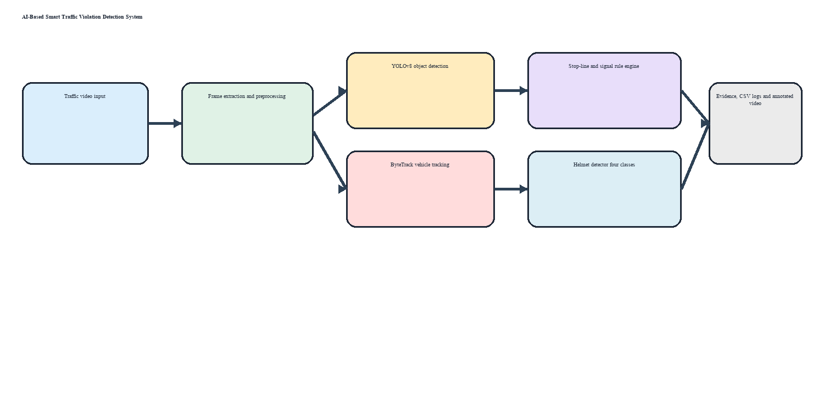
Figure 4.1: System architecture of the proposed system
Figure 4.1: System architecture of the proposed system

4.3 Data Pre-processing
The dataset was checked for image-label pairing, malformed rows, invalid class IDs and coordinates outside the [0,1] range. No malformed label rows or invalid class IDs were found. The dataset was split into 1,545 training images, 438 validation images and 232 held-out test images. Images were resized to 640 × 640 pixels, and YOLO-format labels were retained. No validation images were copied into training data.
- Data cleaning: handling missing values, duplicates and outliers.
- Encoding of categorical data (label / one-hot encoding).
- Normalization / standardization and other transformations.
- Feature selection and train–test splitting.

4.4 Model Selection and Justification
YOLOv8 is a one-stage convolutional object detector that predicts bounding boxes and class probabilities in a single forward pass. It suits video analysis because it provides a practical speed–accuracy trade-off. ByteTrack associates detections across frames using motion and appearance-independent matching, allowing the system to reason about trajectories. The project compares the selected 30-epoch checkpoint against the original weak checkpoint and a separate five-epoch low-learning-rate fine-tune. The 30-epoch checkpoint was selected using validation mAP and balanced detection quality.
ŷ = β₀ + β₁x₁ + β₂x₂ + … + βₙxₙ (4.1)
(Sample equation format – replace with the equations relevant to your model.)

4.5 Algorithm
Algorithm 1: Integrated traffic-violation analysis
Input: Video V, vehicle model, helmet model, stop line L, signal schedule S
Output: Annotated video A, evidence set E, CSV log C
1. Read frames from V and initialise video writer.
2. Detect vehicles, motorcycles and persons using YOLOv8.
3. Update ByteTrack and retain persistent object IDs.
4. Compare tracked vehicle bottom-centres with stop line L and signal state S.
5. For motorcycle tracks, associate rider regions and run helmet classification.
6. Aggregate repeated frame votes to reduce single-frame noise.
7. Save annotated frames, evidence images and structured CSV events.
8. Review flagged events manually before treating them as violations.
Algorithm 1: Integrated traffic-violation analysis
Input: Video V, detector models, stop line L, signal schedule S
Output: Annotated video A, evidence set E, CSV log C
1. Read frames and initialise tracker.
2. Detect vehicles, motorcycles and persons.
3. Update ByteTrack IDs.
4. Test stop-line crossing against signal state.
5. Classify rider helmet condition over repeated frames.
6. Save annotated output, evidence and logs.
7. Review flagged events manually.

4.6 Design Diagrams
The system is primarily software-based. The architecture diagram shows data flow from video input to detection, tracking, rule analysis and evidence output. A use-case view includes an operator submitting video, reviewing flagged events and exporting logs. An activity view follows frame reading, detection, tracking, classification and evidence generation. No dedicated circuit is required.
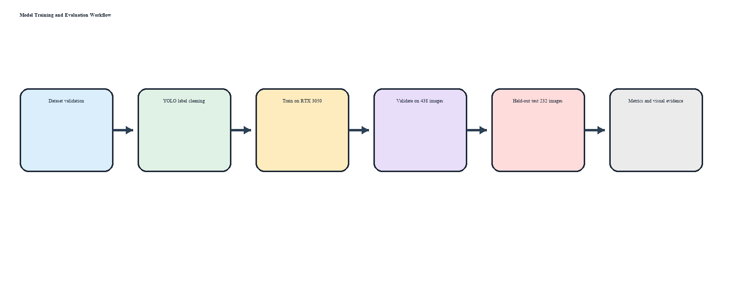
Figure 4.2: Training and evaluation workflow
Figure 4.2: Training and evaluation workflow

4.7 Evaluation Metrics
For object detection, conventional accuracy is not reported because each image may contain multiple objects and localisation quality matters. Precision = TP/(TP+FP), recall = TP/(TP+FN), and F1 = 2PR/(P+R). mAP@50 measures mean average precision at IoU 0.50; mAP@50–95 averages AP over IoU thresholds 0.50 to 0.95. These metrics measure false alarms, missed detections and localisation quality.

CHAPTER 5: IMPLEMENTATION

5.1 Development Environment
Development used Python 3.13, Jupyter Notebook, OpenCV, Ultralytics YOLOv8, PyTorch with CUDA, pandas, NumPy, PyYAML and ByteTrack. Training used an NVIDIA GeForce RTX 3050 Laptop GPU with CUDA-enabled PyTorch. The repository includes a reproducible training helper, requirements.txt, README.md and portable dataset configuration.

5.2 Module Description
Video input module: reads traffic footage and metadata. Detection module: identifies vehicles, motorcycles and persons. Tracking module: assigns persistent IDs with ByteTrack. Red-light module: applies stop-line and signal-state rules. Helmet module: classifies rider crops with four helmet classes and repeated votes. Evidence module: writes annotated video and cropped/full-frame evidence. Logging module: writes CSV summaries and event records. Evaluation module: runs validation/test metrics and saves curves and confusion matrices.

5.3 Sample Code
The complete implementation is provided in Smart_Traffic_Violation_Detection.ipynb and train_helmet_gpu.py. Key implementation choices include project-relative paths, MAX_FRAMES=None for full-video processing, CUDA device selection, persistent tracking IDs, repeated helmet votes, and separate output folders for evidence and logs. The repository README documents setup and execution.
# Representative execution settings
MAX_FRAMES = None
SIGNAL_MODE = "simulate" # demonstration only
HELMET_CONF = 0.25
MIN_NOHELMET_VOTES = 3
# GPU training settings
model.train(data="D:/afaf/work/helmet_dataset/data.yaml", epochs=30, imgsz=640, batch=2, workers=0, amp=False, device=0)

5.4 GitHub Repository
Repository URL: https://github.com/Afafnaurin/AI-Based-Traffic-Violation-Detection-System  Final release commit ID: e01e67f734c124a9d6c018f488a4cc240f2dce23  Contents: Notebook, GPU training helper, README, requirements, portable config and placeholders; large local artifacts excluded | [https://github.com/…]
Final release tag / commit ID
Contents | [Source code, README, requirements.txt, dataset link, trained model]

5.5 Real-time Implementation / Deployment
The delivered prototype is a local, notebook-driven video-analysis application rather than a production web or mobile deployment. An operator supplies a video, configures the stop line and signal mode, runs the pipeline, and reviews annotated videos, evidence images and CSV files. The demonstration uses a simulated signal schedule, so red-light events require manual verification and are not confirmed offences.
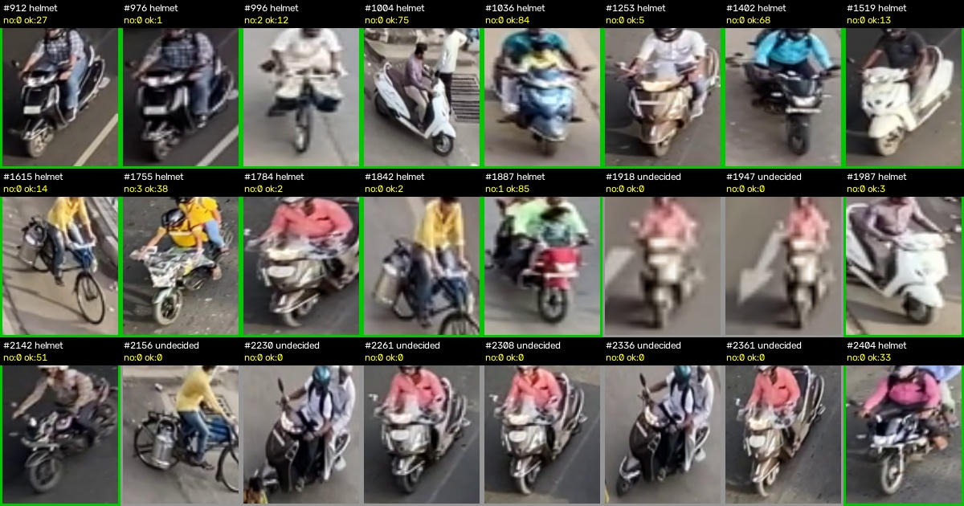
Figure 5.1: Helmet rider contact sheet generated during video analysis
Figure 5.1: Helmet rider contact sheet generated during video analysis

CHAPTER 6: RESULTS AND DISCUSSION

6.1 Experimental Setup
The dataset contains 1,545 training images, 438 validation images and 232 held-out test images. The selected model was trained for 30 epochs at image size 640, batch size 2, workers=0, amp=False and CUDA device 0 on an RTX 3050. A separate five-epoch fine-tune used learning rate 0.0001 and mosaic=0. The evaluation uses the fixed validation and test splits; no validation data was copied into training. The notebook and training helper preserve the paths and settings used.

6.2 Performance Evaluation
Table 6.1: Performance comparison of models
Model | Precision | Recall | F1-Score | mAP@50 | mAP@50–95
30-epoch selected model — validation | 68.83% | 58.04% | 62.98% | 65.32% | 38.56%
5-epoch safe fine-tune — validation | 67.68% | 59.25% | 63.19% | 65.14% | 38.36%
30-epoch selected model — held-out test | 63.91% | 54.61% | 58.90% | 59.03% | 33.57%
The relevant metrics are precision, recall, F1-score, mAP@50 and mAP@50–95. Conventional accuracy, RMSE, MAE and R² are not applicable to this object-detection evaluation.

6.3 Graphical Analysis
Include and interpret plots such as the confusion matrix, ROC curve, actual vs. predicted plot, residual plot, elbow curve or cluster plot.
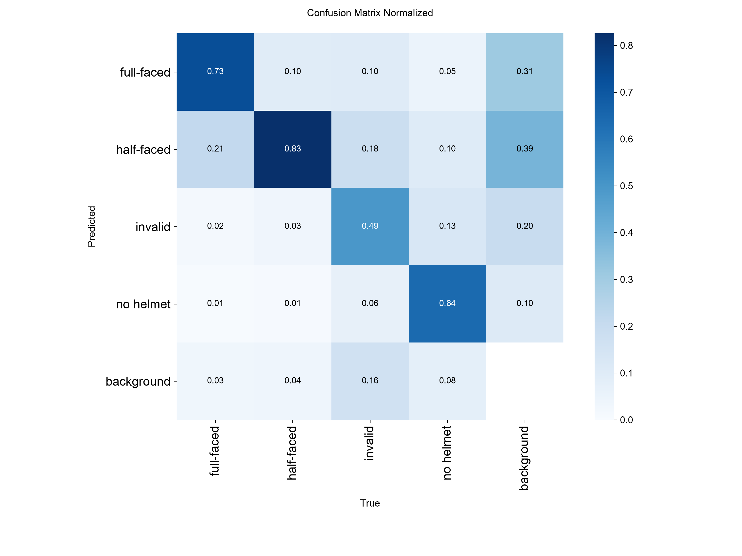
Figure 6.1: Normalized confusion matrix of the selected helmet detector on held-out test data
Figure 6.1: Normalized confusion matrix of the selected helmet detector on held-out test data

6.4 Comparison with Existing Works
The selected model achieved test mAP@50 of 59.03% and mAP@50–95 of 33.57%. These values are lower than some literature reports because datasets, camera views, class definitions, annotation policies and evaluation protocols differ. The selected model is compared fairly with the project baseline and fine-tune under the same validation settings. The five-epoch fine-tune raised recall from 58.04% to 59.25% but reduced mAP@50 from 65.32% to 65.14%, so the original 30-epoch checkpoint remains recommended.

6.5 Observations, Failures and Inferences
The main weakness is no-helmet recall, caused partly by class scarcity and small or occluded rider regions. GPU training initially stalled during an AMP startup check, so a safe run used amp=False and workers=0. Some rider tracks produced no usable helmet vote. The demonstration red-light schedule is simulated. These observations support more diverse data, higher-resolution testing for small riders, real signal-state input and human verification.
Sl. | Issue / Failure Observed | Cause | Solution Applied / Suggested
1 | No-helmet detections are missed | Small class and occluded rider crops | Expand class, collect diverse data, test higher resolution
2 | Initial GPU training stalled | AMP startup check and worker/runtime settings | Use amp=False, workers=0 and batch=2
3 | Some rider tracks have no helmet vote | Poor crop quality or insufficient visible head region | Improve association, crop quality and temporal handling
4 | Red-light events are not confirmed offences | Demonstration uses simulated signal schedule | Use real signal input and retain manual review

6.6 Objectives vs. Outcomes
Objective | Outcome Achieved | Status
Detect vehicles and persons | YOLOv8 detects traffic objects in video | Achieved
Track objects over time | ByteTrack maintains persistent IDs | Achieved
Detect potential red-light violations | Stop-line and signal-state rules generate potential events | Partially; signal is simulated
Detect helmet conditions | Four-class helmet model evaluated on validation and test data | Achieved at prototype level
Generate evidence and logs | Annotated videos, images and CSV files created | Achieved
Evaluate model honestly | Precision, recall, F1, mAP@50 and mAP@50–95 measured | Achieved

CHAPTER 7: CONCLUSION AND FUTURE SCOPE

7.1 Conclusion
The project delivered an integrated prototype for potential red-light and helmet-violation analysis. YOLOv8 and ByteTrack were combined with configurable stop-line rules, helmet classification, evidence extraction and CSV logging. On the held-out test set, the selected helmet checkpoint achieved 63.91% precision, 54.61% recall, 58.90% F1-score, 59.03% mAP@50 and 33.57% mAP@50–95. In the junction demonstration, 1,022 frames produced 121 stop-line crossings, 19 potential simulated red-light events, 74 riders checked and two potential no-helmet events. The objectives were met at prototype level, with operational deployment requiring broader validation.

7.2 Future Scope
Future work should expand the no-helmet class and collect diverse day, night, weather and camera-angle data. Higher-resolution inference can be tested for small rider crops. Real traffic-signal controller input should replace simulation. Number-plate recognition, calibrated confidence thresholds, event deduplication, privacy controls, a review dashboard and a ground-truth traffic-video benchmark would improve usefulness. Any enforcement use should retain human verification and audit logs.

REFERENCES
References are listed in IEEE style and ordered by first citation.
[1] J. Redmon, S. Divvala, R. Girshick, and A. Farhadi, “You Only Look Once: Unified, Real-Time Object Detection,” in Proc. IEEE CVPR, 2016, pp. 779–788.
[2] Jia et al., “Real-time motorcycle helmet detection using an improved YOLOv5 detector,” 2021.
[3] F. Pedregosa et al., “Scikit-learn: Machine learning in Python,” Journal of Machine Learning Research, vol. 12, pp. 2825–2830, 2011. (Journal article)
[4] “Automated Detection of All Kinds of Violations at a Street Intersection Using Real-Time Individual Vehicle Tracking,” study cited in the literature review.
[5] Roboflow Universe, “Motorcycle Helmet Detection Version 2,” [Online]. Available: https://universe.roboflow.com/ (accessed: 26 Oct. 2026).
[6] Ultralytics, “YOLOv8 Documentation,” [Online]. Available: https://docs.ultralytics.com/ (accessed: 26 Oct. 2026).

APPENDIX A: SOURCE CODE
The repository contains Smart_Traffic_Violation_Detection.ipynb, train_helmet_gpu.py, README.md, requirements.txt, configs/helmet_data.example.yaml, .gitignore and output-folder placeholders. Large local datasets, videos and checkpoints are intentionally excluded from Git history. Repository: https://github.com/Afafnaurin/AI-Based-Traffic-Violation-Detection-System

APPENDIX B: SCREENSHOTS
The following figures show the helmet rider contact sheet, validation precision–recall curve, normalized confusion matrix, helmet evidence and simulated red-light evidence. They document model behaviour and output generation. They are evidence of prototype execution, not proof of enforcement accuracy.
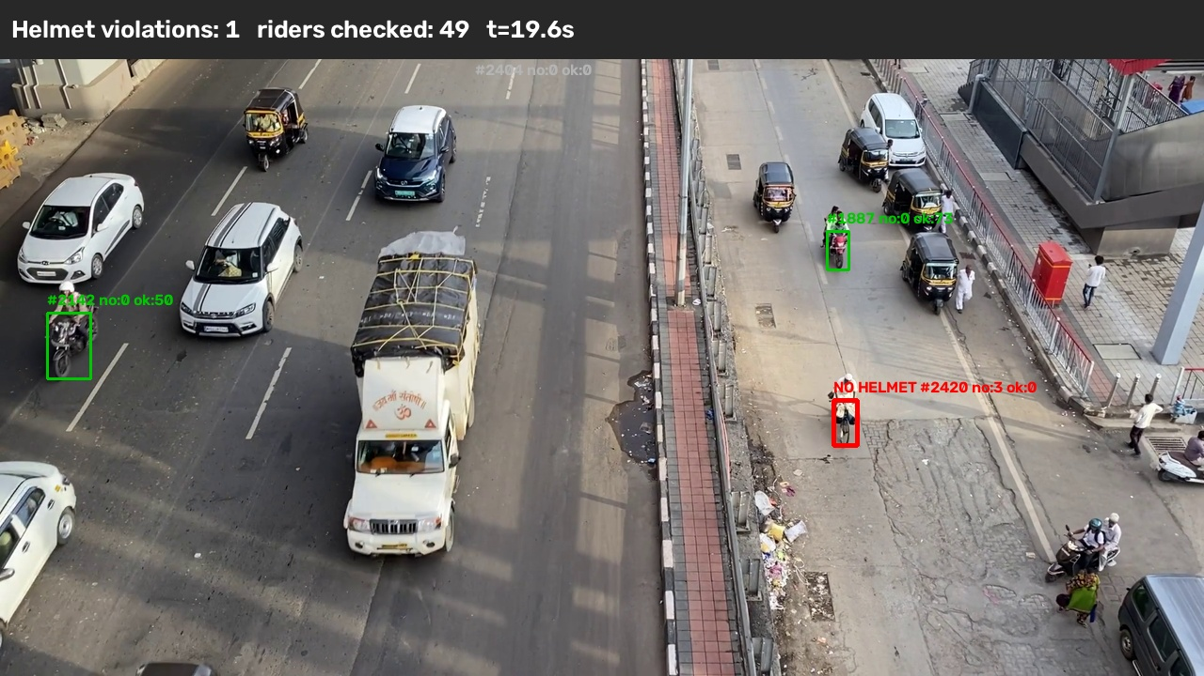
Figure B.1: Example helmet evidence frame; flagged events require human verification
Figure B.1: Example helmet evidence frame; flagged events require human verification

APPENDIX C: MAPPING with SUSTAINABLE DEVELOPMENT GOALS
Sl No | SDG addressed | How demonstrated
1 | SDG 3: Good Health and Well-Being | Assists identification of helmet and signal violations
2 | SDG 9: Industry, Innovation and Infrastructure | Applies AI, computer vision and tracking to transport monitoring
3 | SDG 11: Sustainable Cities and Communities | Provides a prototype for data-assisted urban traffic management
4 | SDG 16: Peace, Justice and Strong Institutions | Creates structured, reviewable evidence logs with human verification

APPENDIX D: INDIVIDUAL CONTRIBUTION OF TEAM MEMBERS
Sl. | Name & Register No. | Modules / Tasks Handled | Contribution (%)
1 | Abiya Elizabeth Jomon – MGP24RA009 | System planning, documentation and testing | 25
2 | Bilal Muhammed S – MGP24RA039 | Video processing, tracking and red-light logic | 25
3 | Fidah Fathima – MGP24ECE023 | Dataset preparation, helmet training and evaluation | 25
4 | Afaf Nourin Rizwan – MGP24ECE004 | Integration, evidence generation, report and repository preparation | 25

